Lab: Trees Representation and Traversal (BFS, DFS)
Write Java code for solving the tasks on the following pages. Code should compile under the Java 8 and above standards you can write and locally test your solution with the Java 13 standard, however Judge will run the submission with Java 10 JRE. Avoid submissions with features included after Java 10 release doing otherwise will result in compile time error.
Any code files that are part of the task are provided as Skeleton. In the beginning import the project skeleton, do not change any of the interfaces or classes provided. You are free to add additional logic in form of methods in both interfaces and implementations you are not allowed to delete or remove any of the code provided. Do not change the names of the files as they are part of the tests logic. Do not change the packages or move any of the files provided inside the skeleton if you have to add new file add it in the same package of usage.
Please follow the exact instructions on uploading the solutions for each task. Submit as .zip archive the files contained inside "...\src\main\java" folder this should work for all tasks regardless of current DS implementation.
In order for the solution to compile the tests successfully the project must have single Main.java file containing single public static void main(String[] args) method even empty one within the Main class.
Some of the problem will have simple Benchmark tests inside the skeleton. You can try to run those with different values and different implementations in order to observe behaviour. However keep in mind that the result comes only as numbers and this data may be misleading in some situations. Also the tests are not started from the command prompt which may influence the accuracy of the results. Those tests are only added as an example of different data structures performance on their common operations.
The Benchmark tool we are using is JMH (Java Microbenchmark Harness) and that is Java harness for building, running, and analyzing, nano/micro/milli/macro benchmarks written in Java and other languages targeting, the JVM.
Additional information can be found here: JMH and also there are other examples over the internet.
Important: when importing the skeleton select import project and then select from maven module, this way any following dependencies will be automatically resolved. The project has NO default version of JDK so after the import you may (depends on some configurations) need to specify the SDK, you can download JDK 13 from HERE.

Your task is to implement the ADS AbstractTree<E> inside the Tree<E> class provided. You have to implement all the methods in order to solve the problems below each problem is a single task, however you are free to add more methods with any access modifier you want.

Create Tree

Implement the Tree class's constructor to set the correct key and to be able to build full tree by accepting all the children for each node. Also make sure to create the proper fields.

Solution:
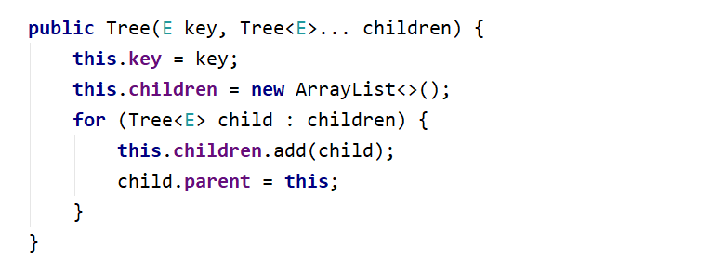

BFS Traversal

Implement the Tree class's public List<E> orderBfs () method which should traverse the elements in order of each level sequentially be careful the order of output matters.

Solution:
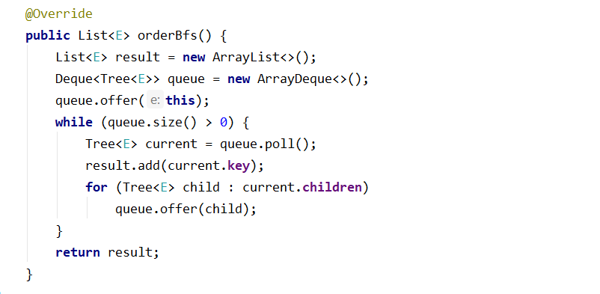

DFS Traversal

Implement the Tree class's public List<E> orderDfs () method which should traverse the elements in terms of descendant before sibling order of each level sequentially be careful the order of output matters.

Solution:
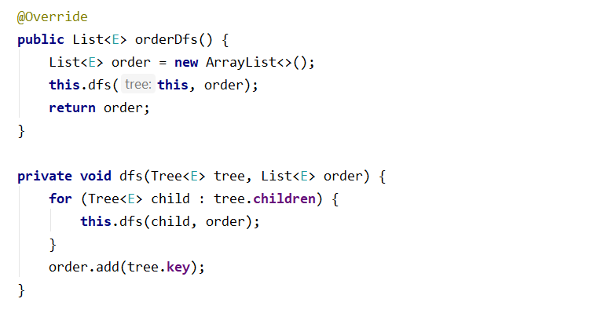

Add Child
This time you have to find a Tree node with a specified key and add a child tree to its children. You have to traverse all the Nodes and find the one with the same key. After that simply attach the child Tree. Make some test of your own to see how you can make a single tree from multiple trees regardless of the sizes of both.

Remove Node
This time you have to find a Tree node with a specified key and remove it from the initial tree. You have to be sure that removing also removes any descendants of that node. Simple example would be if we remove the root of the tree we get empty tree afterwards. If we remove a leaf we only affect that specific node. If we remove node that is parent to leaf/s we remove all leafs that have the node as parent etc… Think of all the possible cases of the remove operation.
For this task the tests will traverse the nodes in BFS order.
Note: if there are no nodes simply return an empty List<E>.
Example:
Initial Tree | Operation | Result Tree
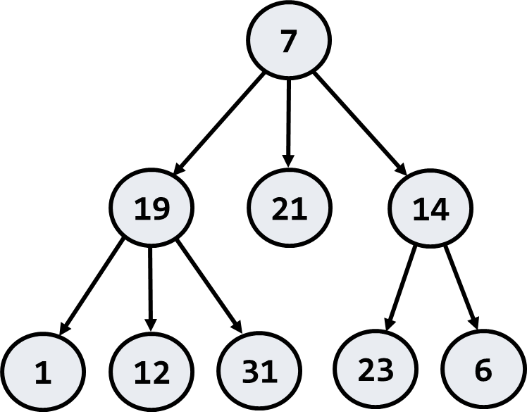 | Remove(19) | 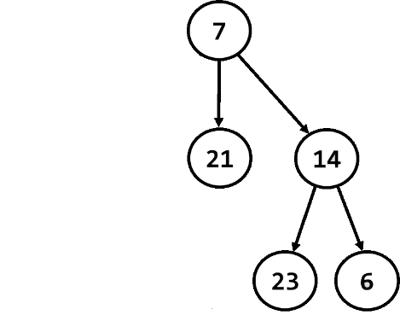

Swap Nodes
This time you have to find a Tree nodes with a specified keys and swap them. Now this problem is a bit harder. But you have all the knowledge required. So what you have to do is swap two nodes alongside their descendants. Keep in mind that swapping should also arrange the references inside the nodes in a proper way. Think about the edge cases what will happen if we attempt to swap the root with a leaf. Or in this order one of the middle nodes with a leaf etc…
For this task the tests will traverse the nodes in BFS order.
Note: if there are no nodes simply return an empty List<E>.
Example:
Initial Tree | Operation | Result Tree
 | Swap(19, 14) | 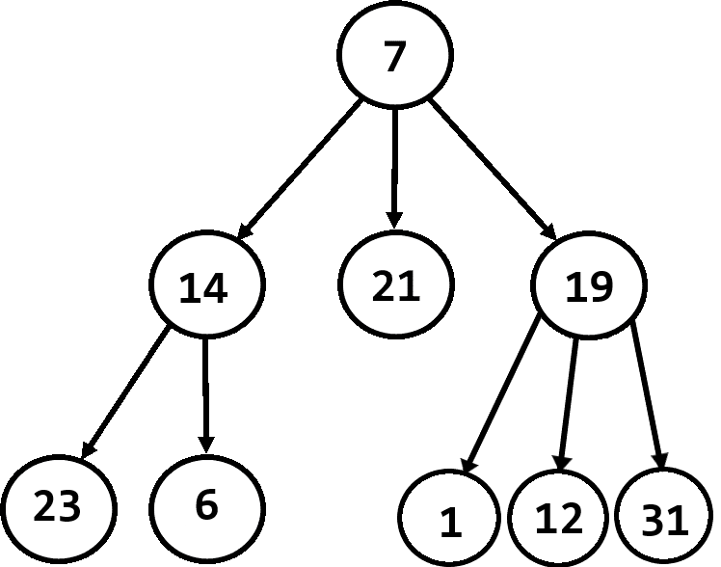

"The first principle is that you must not fool yourself and you are the easiest person to fool." ― Richard Feynman

